

PIPELINE ROW PATROL INSPECTION REPORT

**Targa Resources (HGS)**  
Channelview, Galena Park, Mont Belvieu, and Baytown

June 17, 2025

**CONFIDENTIAL DOCUMENTS**

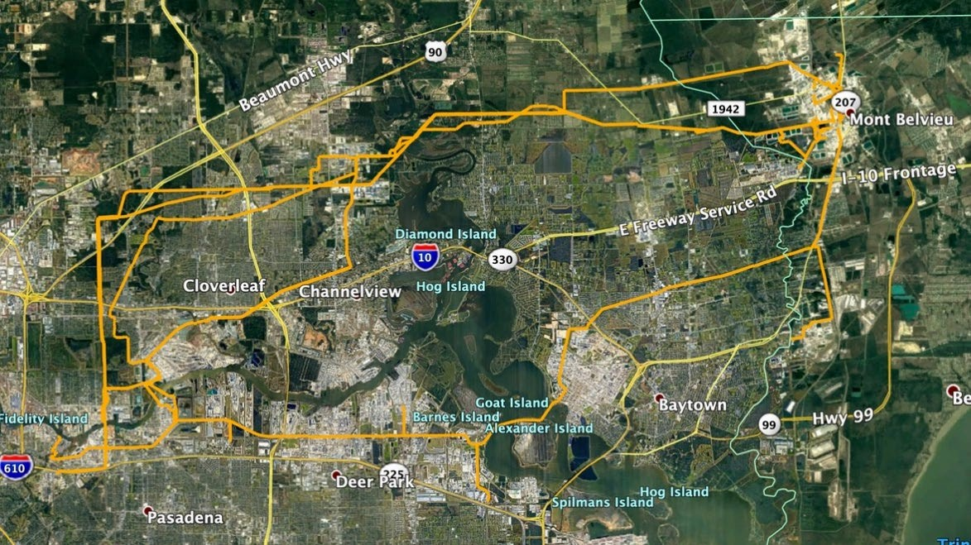

Arch Aerial, LLC

3801 Yale Street

Houston, TX 77018

281.974.5752